BIG DATA LAB

Name: Sunayana M

USN: 1NT19IS165

Date:16.06.2022

**Exercise-3:** MapReduce Use the Hadoop framework to write a custom MapReduce program to perform word count operations on a custom data set.

Initially create a new project, package, and class in eclipse to run a java code.

**To install jar files:**

Right-click on the project (MapReduce)

Click on -> build a path -> add external archives -> Hadoop 3.2.1 -> share

In share

1. Click on common ->open hadoop-common-3.2.1.jar

2. Click on MapReduce -> open hadoop-mapreduce-client-core-3.2.1.jar

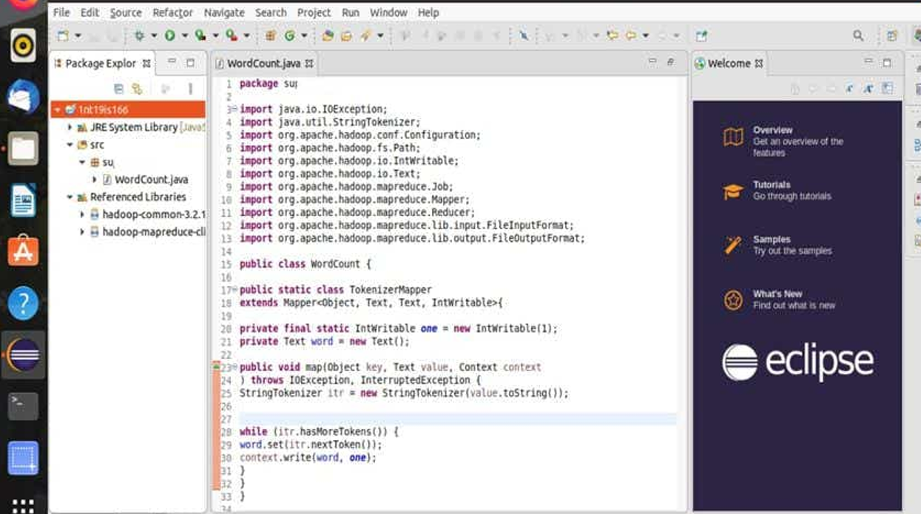

Right click on project -> export -> java -> jar file -> next Browse the address of the java file and save it in desktop/document/downloads and name it (supreetha.jar)

**IN TERMINAL:**

Run the commands:

**cd $HADOOP_HOME**

**cd sbin**

**jps**

**start-all.sh**

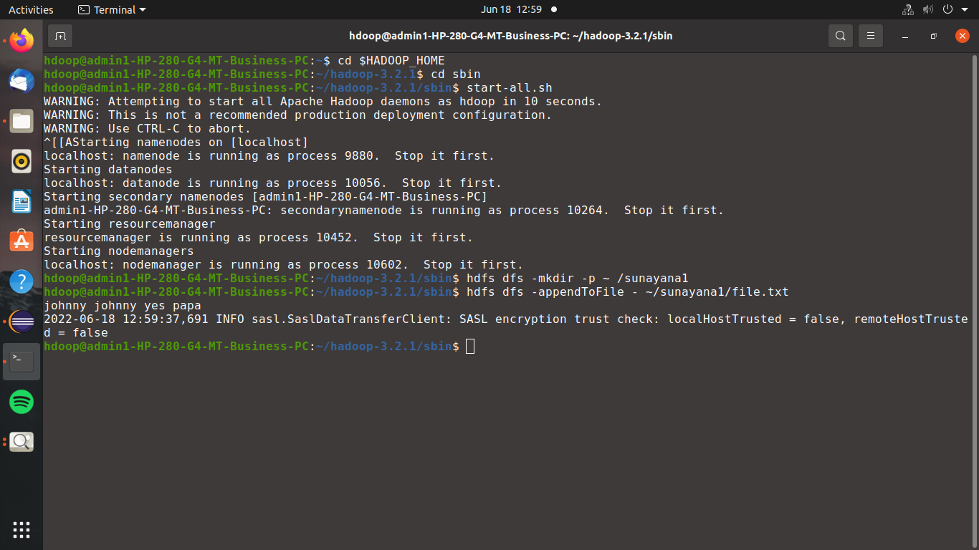

**hdfs dfs -mkdir -p ~ /sunayana1**

**hdfs dfs -appendToFile - ~/sunayana1/file.txt**

Create a file and add content to it. ->(ctrl D two times)

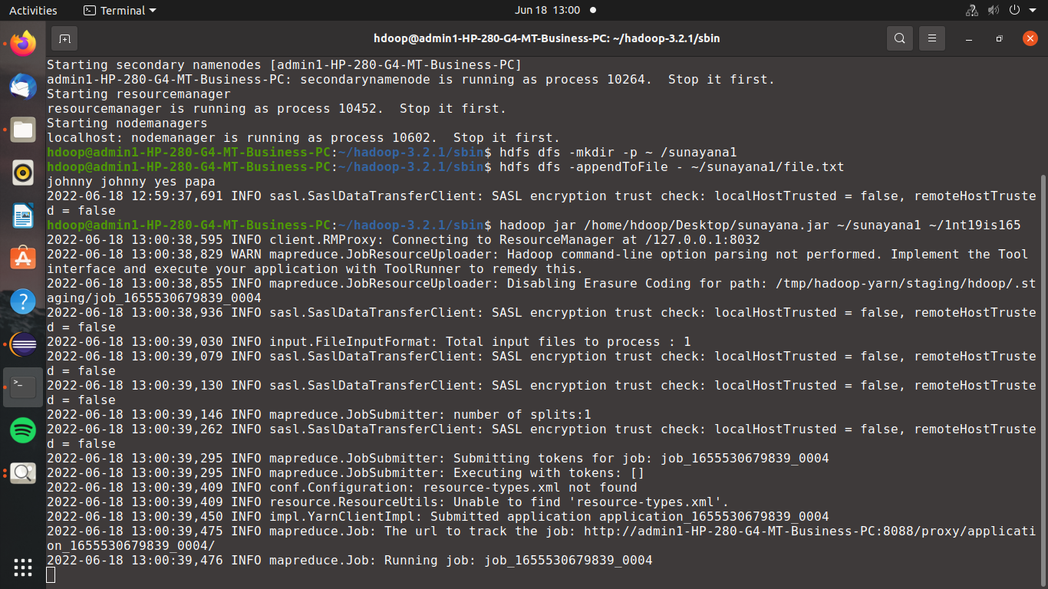

**hadoop jar /home/hdoop/Desktop/sunayana.jar ~/sunayana1 ~/1nt19is165**



**hdfs dfs -cat ~/1nt19is165/part\***

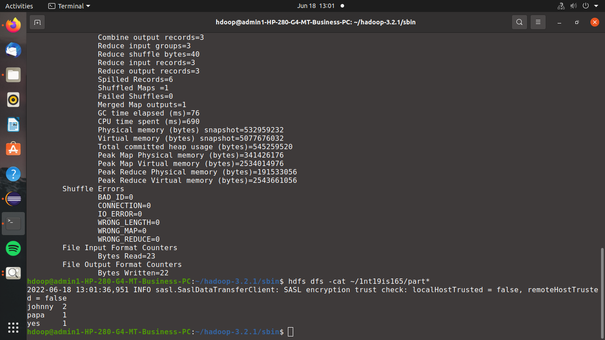

The word count of all the words in the file are

johnny 2

papa 1

yes 1